Slicing and cutting problems
Purpose:
The purpose of this activity is to help your child to make common solid (three-dimensional) shapes and make paper/cardboard patterns for these, and to correctly identify prisms.

Link to NZ Curriculum:
Your child is learning to make paper or cardboard patterns (nets) for common three-dimensional shapes, and to identify prisms by their features.

What you need:
Play dough
A plastic knife, or ‘safe’ kitchen knife
Spare paper or cardboard
Pencil, ruler and eraser
Scissors
Cellotape or glue

What to do:
- Have your child use the dough to make and name a cube, a cylinder, a sphere, a cuboid (long cube or rectangular prism), a square based pyramid, a cone and a triangular prism.
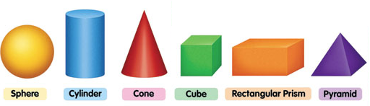

- Have your child talk to you about the distinguishing features of each shape, for example "The square based pyramid has 5 vertices (corners where 3 edges meet), 8 edges (where 2 ‘sides’ or faces meet), and 5 faces of which one is a square and 4 are triangles."
- Have your child chose some of the shapes with straight edges, and using paper or card, make and cut a pattern for this shape. They should include tabs on their pattern so the shape can be folded and glued to make a three dimensional model. For example:
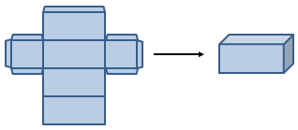
Have your child put their play dough shapes in the fridge while they cut out and glue/tape their paper/cardboard shapes together. Chilling the dough shapes will make them firmer and this will make the next task more successful.
- Now say, “I want you to slice at least twice through each play dough shape. But before you do, I want you to predict which shapes will have slices that are all the same size and shape, and which ones will have slices that are different sizes or shapes.”

- Have them make their prediction and then have them slice through their play dough shapes to see if their predictions are correct.
NB. When a prism is sliced through, its slices are the same size shape, like this:
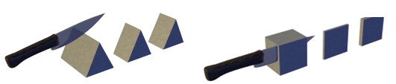
If you slice through a shape that is not a prism, eg, a pyramid, the slices will change shape and size.
So, a prism is a solid object that has two identical ends and all flat sides. The cross section is the same all along its length.
- Talk together about what has happened and together agree which shapes are prisms.

What to expect your child to do:
- Make and name common solid three-dimensional shapes.
- Make paper or cardboard patterns (nets) for common three-dimensional shapes.
- Identify features of prisms.

