Shape game 2
Purpose:
The purpose of this activity is to help your child to make and correctly name common (3 dimensional) solid shapes, talk about their distinctive features, and also about the flat shapes they can see on their solid shape.

Link to NZ Curriculum:
Your child is learning to sort objects by their spatial features, name these, and recognize two-dimensional shapes that are the faces of 3 dimensional shapes.
NB. The flat shapes of the faces or ‘sides’ are two-dimensional shapes are also known as ‘plane shapes’.

What you need:
Play dough
A plastic knife, or ‘safe’ kitchen knife

What to do:
- Have your child use the dough to make a cube, a cylinder, a sphere, a cuboid (long cube or rectangular prism), a square based pyramid and a cone.
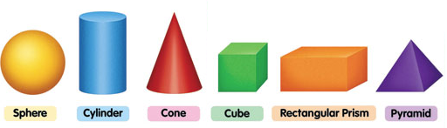
- Ask them to name the shapes one at a time and tell you about the features of each. These should include the number of vertices (‘corners’) it has, the number of edges it has, and the number of flat faces (‘sides’).
For example "The square based pyramid has 5 vertices (corners where 3 edges meet), 8 edges (where 2 ‘sides’ or faces meet), and 5 faces, of which one is a square and 4 are triangles."
Now play a game in which you take turns to make a solid shape with the dough, but do not let the other person see the shape.
Take turns to ask specific questions about the shape, using the features identified above, until the shape is correctly identified by the person who is guessing.
For example: Your child makes a shape that you can’t see. You ask, “Has it got 5 vertices?” Your child says, “No.” You now know that they have not made a pyramid. You then ask, “Has your shape got 2 faces that are circles?” (You are thinking of a cylinder). Your child says, “No.” and so on.

What to expect your child to do:
- Correctly make and name common three-dimensional shapes.
- Correctly identify the features of common three-dimensional shapes.
- Name the two-dimensional (plane) shapes (squares, circles, triangles, oblongs/rectangles) that are the faces. For example, a cube has 6 faces (‘sides’) that are squares.

